**CP Club 365 Days Challenge**

**Programming language – C++**

**Problem Statement**

<https://www.codechef.com/START71C/problems/PERFECTTRIO>

**Your Code**:

// 0x73Day of 0x365Days challenge

// VEDANT BHARAD

// 29-12-2022

#include <bits/stdc++.h>

using namespace std;

string Trio(int a[]) {

    if(a[0]==(a[1]+a[2]))

        return "YES";

    return "NO";

}

int main() {

    int t;

    cin >> t;

    while (t--) {

        int arr[3];

        for (int i = 0; i < 3; i++) {

            cin >> arr[i];

        }

        sort(arr, arr + 3, greater<int>());

        cout<<Trio(arr)<<endl;

    }

    return 0;

}

**Output (Screen Shot)**:

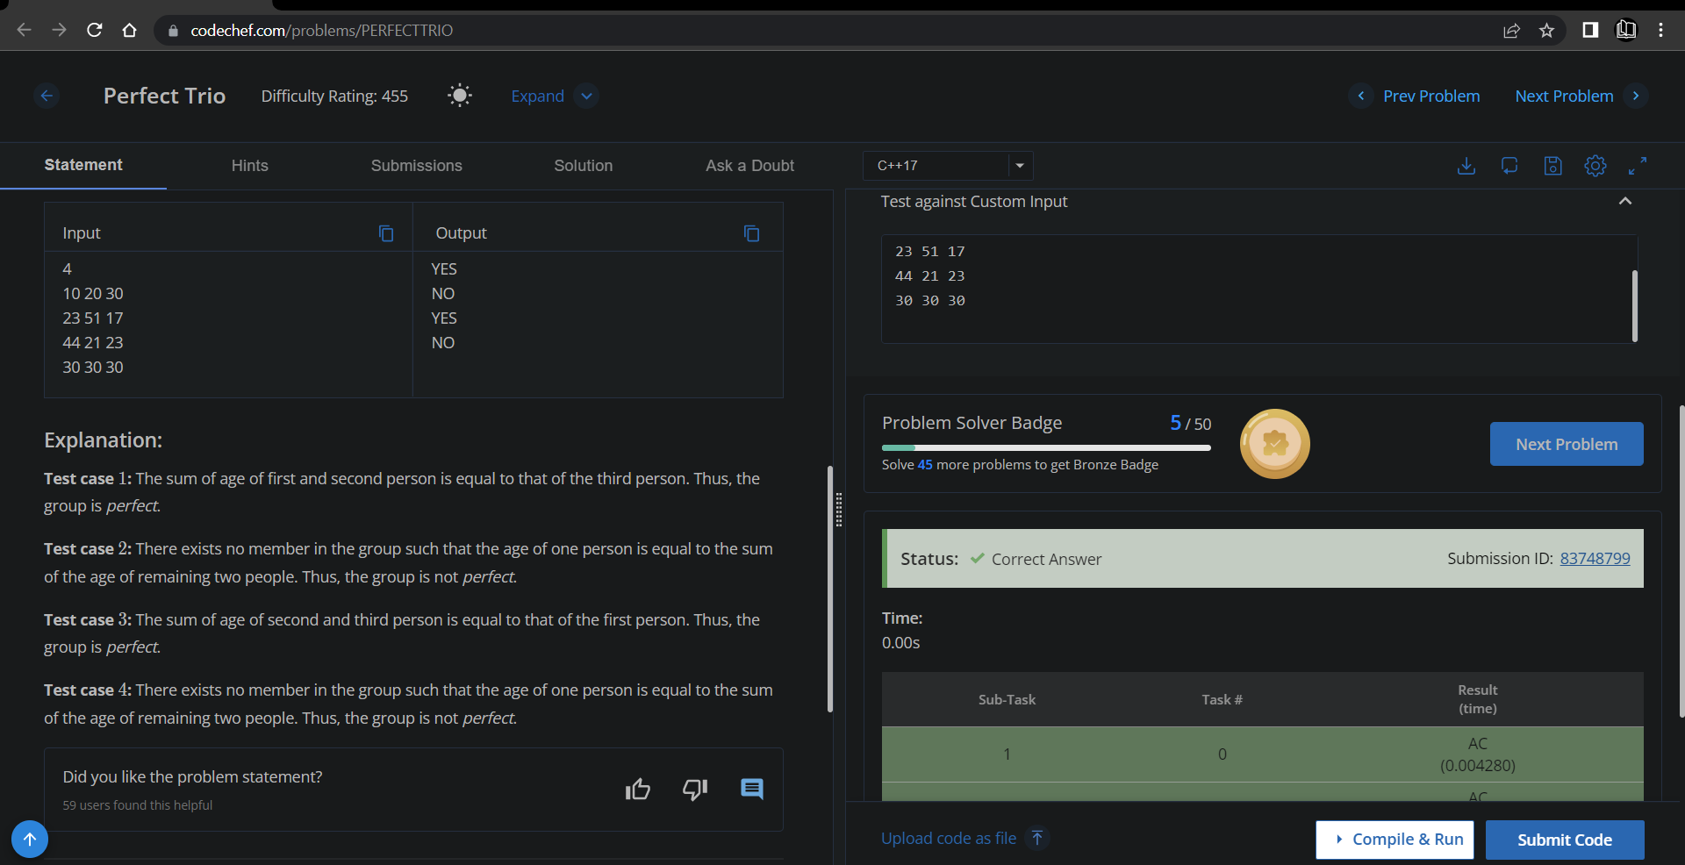

**Understanding about problem:**

* In this task I need to check whether the group of three numbers is perfect group or not and return YES if it is perfect group else return NO.

Note: If you can't understand the problem, feel free to contact us and we'll help you. Please don't copy and paste from anywhere.

ALL THE BEST

Team CP Club